#### CAS MA 584 / CDS DS 522

Stochastic Methods for Algorithms

Table of Contents

Overview 2

Welcome / About This Course 2

Learning Outcomes 3

Prerequisites 4

Logistics 4

Class Meetings 5

Equity/Inclusion 6

Assignments 6

Grades 7

Philosophy 7

Determining Your Course Grade 9

Grading Criteria 10

Revising and Resubmitting Work 11

Collaboration and Academic Honesty 12

Hub Learning Outcomes 13

Tentative Schedule 15

Community of Learning: Additional Class and University Policies 16

# Overview

**Instructor** Jonathan Huggins  
**Office** MCS 233E  
**Office Hours** TBD

**Lecture** Times: TBD  
Location: TBD

**Textbook** *Stochastic Methods for Algorithms* (available through the course website)  
**Course Content** Blackboard   
**Communication** Campuswire  
**Other software** LaTeX editor(e.g., Overleaf, TeXShop, TeXstudio, or LyX)

**Hub Units** Creativity/Innovation (CRI) and Writing-Intensive Course (WIN)  
**Prerequisites** See below

## Welcome / About This Course

“There is nothing more practical than a good theory.” – Kurt Lewin

This course concerns the use of stochastic processes for designing and analyzing algorithms, with a focus on applications in statistics and machine learning. You will learn about core concepts and results about stochastic processes, then use this machinery to develop algorithms and/or characterize their statistical and numerical properties. The two recurring applications will concern (large-scale) optimization using stochastic gradients and sampling from complex distributions such as Bayesian posterior distributions and energy-based models. In addition to statistics and machine learning, these optimization and sampling algorithms derived and analyzed have diverse applications including to problems in computer science, physics, chemistry, ecology, biology, and operations research. As such, a strong emphasis will be placed on the ability to describe and investigate the practical implications of the results.

Considering the application-oriented motivations, the stochastic processes material focuses on intuitive understanding of definitions and theoretical properties rather than their rigorous development. This approach will allow us to almost immediately begin to investigate algorithms and their properties. Toward the same ends, we will mostly forgo using advanced tools probability theory and functional analysis. Thus, we will tend not to dwell on regularity conditions and other (still important!) technicalities. However, throughout the course I will provide pointers to sources where rigorous treatments can be found.

When describing the practical implications of algorithm analyses and empirical results aimed at validating such analyses, clear communication is a must. Thus, you will do a significant amount of expository writing in this course. These writing opportunities will enable you to learn how to synthesize complex mathematics and sophisticated experiments in a clear way that can be understood by someone who is familiar with the underlying algorithms but not the mathematical theory.

## Learning Outcomes

After successful completion of this course, you will be able to…

1. Explain how to use the theory of Markov chains and stochastic differential equations to analyze Markov chain Monte Carlo and stochastic optimization algorithms.
2. Evaluate the implications of theoretical analyses of Markov chain Monte Carlo and stochastic optimization algorithms, including law of large numbers, geometric ergodicity, central limit theorems, error analyses, and scaling limits.
3. Interpret results and arguments in the modern statistics and machine learning literature about the design and analysis of Markov chain Monte Carlo and stochastic optimization algorithms.

## Prerequisites

The formal prerequisites are (recommended versions marked with a *):

* **Writing** *[undergraduate only]***:** First-Year Writing Seminar (e.g., WR 120)
* **Programming:** CAS CS111, CDS DS110, ENG EK125, or equivalent.
* **Vector calculus:** CAS MA225, CAS CS235, CDS DS122, or equivalent
* **Linear algebra:** CAS MA242, CAS CS132, CDS DS121, or equivalent
* **Probability theory:** *CAS MA581, CAS CS237, ENG EK381, *ENG EK500, or equivalent.

However, there are some additional “soft” requirements/recommendations that do not correspond to a specific course:

* You must **be** **able** **to write scientific code** in either Python or R. For example, you may have taken CAS MA415, CAS MA615, CDS DS210, or a more advanced CS programming course.
* You must **have** **experience writing rigorous mathematical proofs**, with proofs by induction being particularly important. For example, you may have taken one or more 500-level proof-based math courses or a course on analysis algorithms, or a computer science theory course.
* Some **previous exposure to stochastic process theory** will be invaluable but is not strictly required. For example, you may have taken CAS MA583, CAS MA783, or ENG EC505.
* Some **previous exposure to statistics and/or machine learning** – particularly regression, statistical models, Markov chain Monte Carlo, and/or (stochastic) optimization – is helpful but not required.

## Logistics

All course content will be on Blackboard and all work will be submitted through Blackboard. Communication will be done strictly through Campuswire. I will not answer emails.

I encourage you to come to office hours sometime in the first month of class, as I would very much like to get to know you all. As the semester gets going, you can come to office hours to discuss the class material – or math, statistics, and ML in general. If you can’t make office hours or if you need to talk to me privately, please email me, and I will do my best to schedule a time for us to meet.

## Class Meetings

Your work in the class will follow a pattern that will involve you **before**, **during**, and **after** our meetings:

* **BEFORE each class**: You'll complete a **Daily Prep** assignment in which you'll read parts of the text and complete assignments that will get you up to speed on the basic ideas of new material.
* **DURING each class**: Class time is reserved for solving math and writing code, both together and individually. We will focus on activities that **apply the basics** that you learn in Daily Prep and get you ready for more advanced work later.
* **AFTER each class**: You'll apply and extend the ideas we practice during class through different kinds of graded work.

Since you learn best by *doing* an activity, class time will be prioritized for doing active work (both individually and in groups) on applications of basic concepts, including reading and writing of proofs, mathematical exposition, and code. You'll be expected to gain enough fluency on those basics to be productive in class, by doing your Daily Prep assignments. Lectures during class will be infrequent, short, and targeted at specific questions from your work rather than a general introduction to concepts. Also, **there are no timed tests or quizzes during class meetings**.

# Equity/Inclusion

As your professor, I pledge to work to create an equitable learning environment where all students belong. Statistics can seem like an “objective” subject, but like all education, mathematical education is a cultural activity, and many aspects of who we are affect how we experience statistics classes. There is considerable research on how students’ “sense of belonging” in their classes impacts their learning. Feeling like you don’t belong in a class can impact your cognitive load and diminish your ability to focus on the mathematical and statistical content; so, for example, you might use your brain to worry whether the professor or your classmates will think you’re stupid if you make a mistake; to deal with the impact of a racist, sexist, classist, xenophobic, homophobic, transphobic, or ableist comments; or to wonder whether the other students are better than you.

Although frustration and struggle are also part of the educational enterprise, ultimately, I see my work as setting up situations where all students can experience the joy of mathematics and statistics, to feel a sense of belonging, and to use our brains for learning.

# Assignments

There will be four types of assignments:

1. **Daily Prep.** Daily reading with exercises and questions to be submitted prior to class. These will help you learn the basics of new material and prepare you for higher-level focused work in class. There are 24 of these planned.
2. **Problem Sets.** More challenging problems with a mix of derivations, proofs, and coding problems. Parts of the problem sets will allow for collaboration and peer feedback within pre-assigned groups. The rest must be done individually. There are 6 of these planned.
3. **Deep Dives.** These ask you to delve into more complicated proofs and implement more sophisticated numerical experiments to empirically investigate the theoretical results you learn about. There are 3 of these planned.
4. **Final Project.** The final project will involve further investigation of a topic closely related to what is covered in the course by reading research papers. The project will involve a mix of algorithm development, algorithm analysis, mathematical exposition, and numerical experiments. Further details will be provided later.

There is no final exam in this course.

# Grades

## Philosophy

Your grade in the course is earned by **demonstrating evidence of skill on the main concepts in the course** and by **showing appropriate engagement with the course**. And this is done by completing the assignments outlined above, at a reasonably high level of quality. The class should be a learning community, where students support each other to increase everyone’s learning. You should not be competing with other students for grades. You should have some choice in your trajectory through the course.

Therefore, in this course, **there are no points or percentages** on any items. Instead, the work you turn in will be evaluated against **quality standards** that will be made clear on each assignment. If your work meets the standard, then you will receive full credit for it. Otherwise, you will get helpful feedback and, on most items, the chance to reflect on the feedback, revise your work, and then resubmit it for regrading.

This feedback loop represents and supports the way that people learn: By trying things, making mistakes, reflecting on those mistakes, and then trying again. **You can make mistakes without penalty** if you *eventually* demonstrate evidence of skill.

## Determining Your Course Grade

The individual kinds of assignments are marked as follows:

|  |  |
| --- | --- |
| Assignment | How it’s marked |
| Daily Prep | **Pass** or **No Pass** |
| Problem Sets | **E** (excellent), **M** (meets expectations), **P** (progressing), or **X** (not assessable) |
| Deep Dives | **E** (excellent), **M** (meets expectations), **P** (progressing), or **X** (not assessable) |
| Project | **E** (excellent), **M** (meets expectations), **P** (progressing), or **X** (not assessable) |

The criteria for each mark are explained below in the “Grading Criteria” section below.

Your final grade in the course is determined by the following table. Each grade has a *requirement* specified in its row in the table. **To earn a grade, you will need to meet *all* the requirements in the row for that grade.** Put differently, your grade is the **highest** grade level for which **all** the requirements in a row of the table have been met or exceeded.

|  |  |  |  |  |
| --- | --- | --- | --- | --- |
| Grade | Daily Prep | Problem Sets | Deep Dives | Final Project |
| A | 20 passed | 5 E/M with at least 1 E | 3 E/M with at least 1 E | E/M |
| B | 18 passed | 4 E/M | 3 E/M | E/M |
| C | 16 passed | 3 E/M | 2 E/M | E/M |
| D | 12 passed | 1 E/M | 1 E/M | n/a |

A grade of **F** is given if all the requirements for a **D** are not met.

**Additional grade factors:**

* **Plus/minus grades:** Plus/minus grades will be assigned at my discretion based on how close you are to the next higher or lower grade level. Receiving an **E** on one or more deep dives and/or problem sets will tend to increase your grade.
* **Final Project:** 
  + If you receive an **E** on the final project, your grade will increase by one increment (e.g., B to B).
  + If you receive an **P** on the final project, your grade will decrease by one increment (e.g., B to B-)
  + If you receive an **X** on the final project, your grade will decrease by two increments (e.g., B to C+)

## Grading Criteria

* **Daily Prep:** A **Pass** mark is given if the Daily Prep is turned in before its deadline and if each item on the Daily Prep has a response that represents a good faith effort to be right. Mistakes are not penalized. A **No Pass** is given if an item is left blank (even accidentally), has an answer but it shows insufficient effort (including responses like "I don't know"), or if the Daily Prep is late.
* **Problem Sets**, **Deep Dives**, and **Final Project**. Each type has its own standards for “acceptable work” outlined in the *Standards for Grading* document available on Blackboard. The grading process is outlined in the flowchart on the next page.

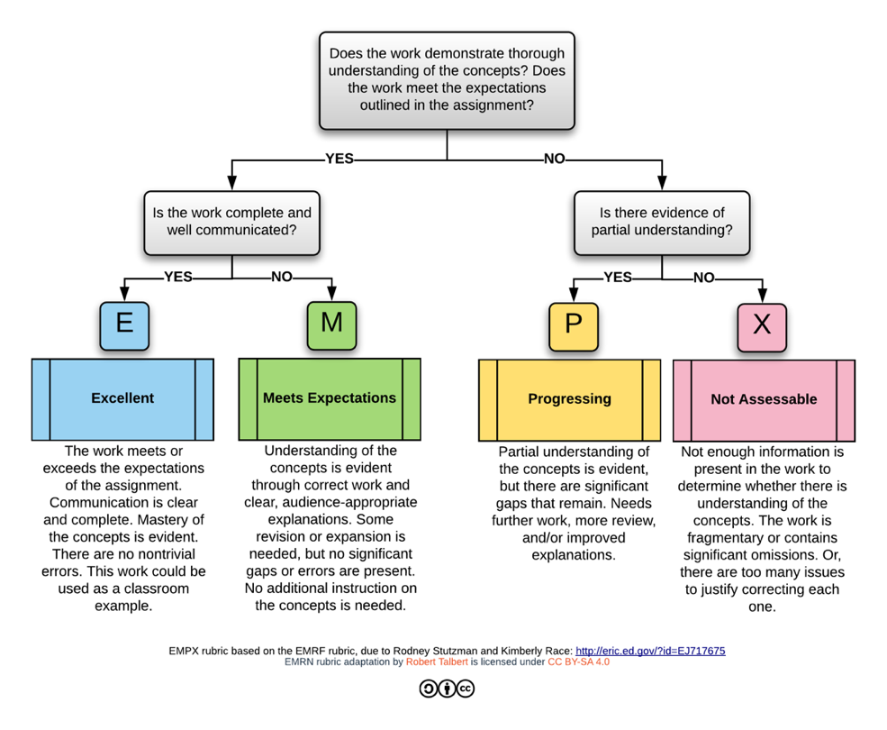

## Revising and Resubmitting Work

Instead of earning partial credit, on most assignments you will have the opportunity to revise and resubmit your work based on feedback that I provide, if the work doesn't meet its standard for acceptability. **Mistakes, and work that does not meet the standard for acceptability, are typically not penalized.** Instead, if your work has enough errors that it would benefit from redoing parts of it or the whole thing, you'll get the chance to do so. This again is because **human beings learn from making mistakes and fixing them with feedback and reflection.**

* **Daily Prep** assignments *may not* be revised or resubmitted. They are graded on completeness and effort only, and therefore can only be done once.
* Each **Problem Set** may be revised **twice**. One problem set revision may be submitted each week. To revise, simply reflect on the feedback that's given, make corrections or rewrites to the original, and then upload the work again to Blackboard.
* Each **Deep Dive** may be revised **once**. To revise, simply reflect on the feedback that's given, make corrections or rewrites to the original, and then upload the work again to Blackboard.
* **Final Project:** The project may not be revised, but you will have the chance to get feedback on a draft.

## Collaboration and Academic Honesty

I highly encourage you to collaborate with your classmates whenever collaboration is allowed. However, realize that *collaboration is not always allowed,* and, in all cases, there are limitations on how you can collaborate. In particular:

* On **Problem Sets** and **Deep Dives**, your work must represent *your own understanding* in *your own words*. You may not use solutions, directly or indirectly, from any sources not explicitly allowed – including other students, past students, online sources, or other textbooks.
* On **all other assignments**, you may collaborate with others, but you must contribute significantly to the assignment, and your work must represent *your own understanding* in *your own words*.

You are responsible for understanding this policy and [Boston University’s Academic Conduct Code](https://www.bu.edu/academics/policies/academic-conduct-code/). Violations will result, at minimum, in a mark of **X** or **No Pass** on the assignment. Serious or repeat violations of this policy will result in increasingly unfortunate consequences, including being barred from further submissions of the assignment, or even failure of the class.

# Hub Learning Outcomes

**Creativity/Innovation**

Students will earn a Creativity/Innovation credit by satisfy the learning outcomes as follows:

1. *Students* *will demonstrate understanding of creativity as a learnable, iterative process of imagining new possibilities that involves risk-taking, use of multiple strategies, and reconceiving in response to feedback, and will be able to identify individual and institutional factors that promote and inhibit creativity.*
2. *Students will be able to exercise their own potential for engaging in creative activity by conceiving and executing original work either alone or as part of a team.*  
   Students will demonstrate creativity in structuring and creating original mathematical proofs and implementing numerical experiments to validate their results. Students will improve their solutions and results on assignments through an iterative process of peer and instructor feedback. Students will be asked to show increasing degrees of creativity in the progression from Problem Sets to Deep Dives to the Final Projects. The Final Project will especially push students to develop new algorithms, implement those algorithms, and investigate their mathematical properties. Overall, students will exercise their own potential for creativity in all three assignment types, which will include both individual and small-group work.

**Writing-Intensive Course**

Students will earn a Writing-Intensive Course credit by satisfy the learning outcomes as follows:

1. *Students will be able to craft responsible, considered, and well-structured written arguments, using media and modes of expression appropriate to the situation.*  
   Students will write formal mathematical proofs and expository explanations of mathematical and experimental results through In-class Exercises, Problem Sets (4–8 pages total), Deep Dives (9–12 pages total), and the Final Project (10–15 pages). They will improve the clarity and style of their writing through peer and instructor feedback, which they will incorporate into revisions that they will resubmit. The course grade will be almost completely determined by student performance on these three assignment types.
2. *Students will be able to read with understanding, engagement, appreciation, and critical judgment.*By completing structured Problem Sets and homework readings from the primary literature, students will learn how to (i) read, understand, and deconstruct complex mathematical proofs and (ii) analyze and critically judge numerical experiments designed to support mathematical theory of algorithms. Readings will also be discussed during class in small groups and with the whole class. Students will also learn how to read and respond to each other’s writing in ways that are beneficial and useful. As a class and in smaller groups, including instructors and students, students will learn how to give and respond to feedback on assignments.
3. *Students will be able to write clearly and coherently in a range of genres and styles, integrating graphic and multimedia elements as appropriate.*N/A

# Tentative Schedule

The following is a tentative list of topics, which I may adjust based on interest and time:

|  |  |  |  |
| --- | --- | --- | --- |
| Week | Reading | Topics | Due |
| 1 | Ch. 1;  App. A | review of probability theory, proof techniques, and scientific programming |  |
| 2 | Ch. 2 | Markov chains; stochastic gradient descent (SGD) | Problem Set 0 |
| 3 | Ch. 2 cont. | Markov chains continued; Markov chain Monte Carlo (MCMC) | Problem Set 1 |
| 4 | Ch. 3 | convex analysis; Taylor approximation; error of SGD |  |
| 5 | Ch. 3 cont.; Ch. 4 | error of SGD continued; metrics on probability spaces | Problem Set 2 |
| 6 | Ch. 4 cont.; Ch. 5 | convergence to stationarity of SGD; small sets and irreducibility; ergodicity of MCMC algorithms | Deep Dive 1 |
| 7 | Ch. 5 cont.; Ch. 6 | law of large numbers for MCMC algorithms; Lyapunov functions; geometric ergodicity of MCMC algorithms | Problem Set 3 |
| 8 | Ch. 7 | martingales; MC central limit theorems | Final Project Proposal |
| 9 | Ch. 7 cont.; Ch. 8 | MC central limit theorems continued; stochastic differential equations (SDEs) | Problem Set; Deep Dive 2 |
| 10 | Ch. 8 cont.; Ch. 9 | SDEs continued; probabilistic aspects of SDEs |  |
| 11 | Ch. 9 cont. | probabilistic aspects of SDEs continued; Langevin algorithms; error analysis of the unadjusted Langevin algorithm | Problem Set 5 |
| 12 | Ch. 10 | scaling limits; optimal scaling of MCMC algorithms | Deep Dive 3;  Final Project Draft |
| 13 | Ch. 10 cont. | scaling limits of SGD; final project time | Problem Set 6 |
| Exam |  |  | Final Project |

I reserve right to make changes to the assessment system and to other aspects of the syllabus to better meet the needs of students in the class. If appropriate, students might have input into these changes. Any changes will be clearly documented with sufficient notice for students to adapt.

# Community of Learning: Additional Class and University Policies

**Accommodations for Students with Documented Disabilities**

If you are a student with a disability or believe you might have a disability that requires accommodations, please contact the Office for Disability Services (ODS) at (617) 353-3658 or [access@bu.edu](mailto:access@bu.edu) to coordinate any reasonable accommodation requests. ODS is located at 19 Buick Street.

**Attendance & Absences**

Attendance is critical to your success in this course, and if you want to do well, you need to be present and prepared. In this class you’ll be part of a learning community, and we will miss you when you aren’t here. However, there are many reasons why people need to miss labs and discussions, such as illness, religious holidays, family emergencies and milestones, civic responsibilities (jury duty, citizenship ceremonies, etc.), dangerous commutes during bad weather, etc. If you know in advance that you’re going to miss a lab or discussion section, please let the lab instructor or TF know. If you do miss a lab or discussion section, it’s your responsibility to find out what you missed.

If there’s something in your life that’s interfering with your ability to engage in the course, please come talk to me about it (you only need to share the details you want to share). Note that you don’t need to bring me doctor’s notes; I don’t read them. Also note that I have considerable experience with chronic illness and how it impacts academic life.

**Incompletes**

If you have health issues, an emergency, or find yourself in other difficult circumstances that affect your performance in the course, you may be eligible for an incomplete, where you would finish the work after the semester ends. Please feel free to talk to me about this possibility.

## Acknowledgments

Parts of this syllabus are borrowed from / based on the syllabi of Debra Borkovitz (BU, CAS MA 293) and Robert Talbert (GVSU, MTH 350).